**DAILY ONLINE ACTIVITIES SUMMARY**

|  |  |  |  |  |  |  |  |
| --- | --- | --- | --- | --- | --- | --- | --- |
| **Date:** | 16-06-2020 | | | | **Name:** | Gudugunti Anirudh | |
| **Sem & Sec** | IV - A | | | | **USN:** | 4AL18CS023 | |
| **Online Test Summary** | | | | | | | |
| **Subject** | | Complex analysis, probability and statistical methods | | | | | |
| **Max. Marks** | | 30 | | **Score** | | 26 | |
| **Certification Course Summary** | | | | | | | |
| **Course** | Data structures and algorithms in c++ | | | | | | |
| **Certificate Provider** | | | Udemy | **Duration** | | | **2.5hr** |
| **Coding Challenges** | | | | | | | |
| **Problem Statement:**  1: program to binary reversal of a number. | | | | | | | |
| **Status:** Completed | | | | | | | |
| **Uploaded the report in Github** | | | | yes | | | |
| **If yes Repository name** | | | | https://github.com/alvas-education-foundation/anirudh_gudugunti/tree/master/daily_progress | | | |
| **Uploaded the report in slack** | | | | yes | | | |

**Online Test Details:** The test for today was from module 1. The test was of objective type questions and there were 30 questions and the duration was 45 minutes. The questions were optimal and easy. The score that I got was 26/30.

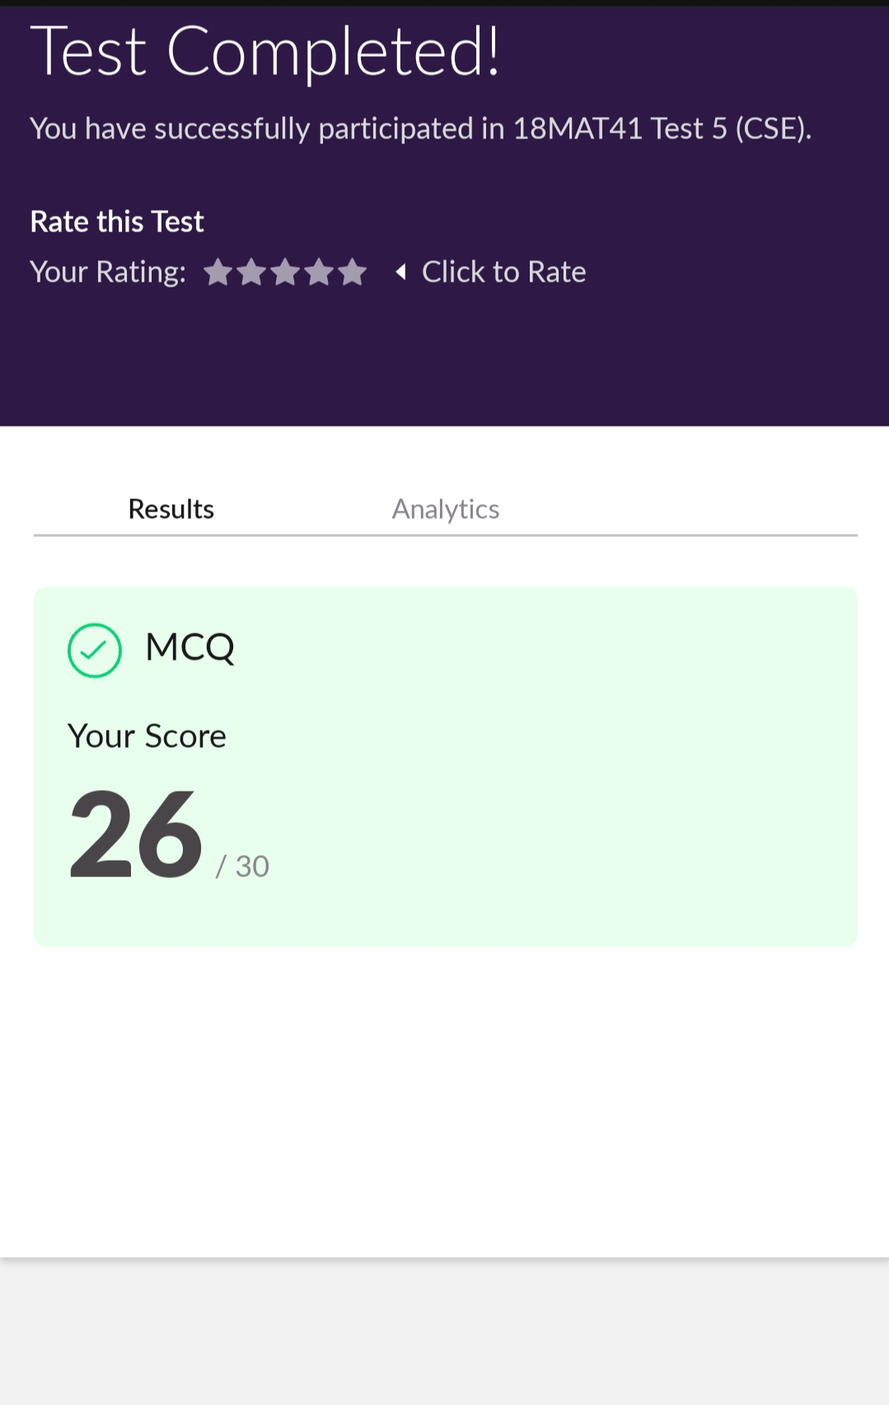

**Snapshot of certification course**:

I have successfully completed 2.5 hrs of basics of data structures and algorithms in c++ through Udemy.

Here is the certificate of completion.

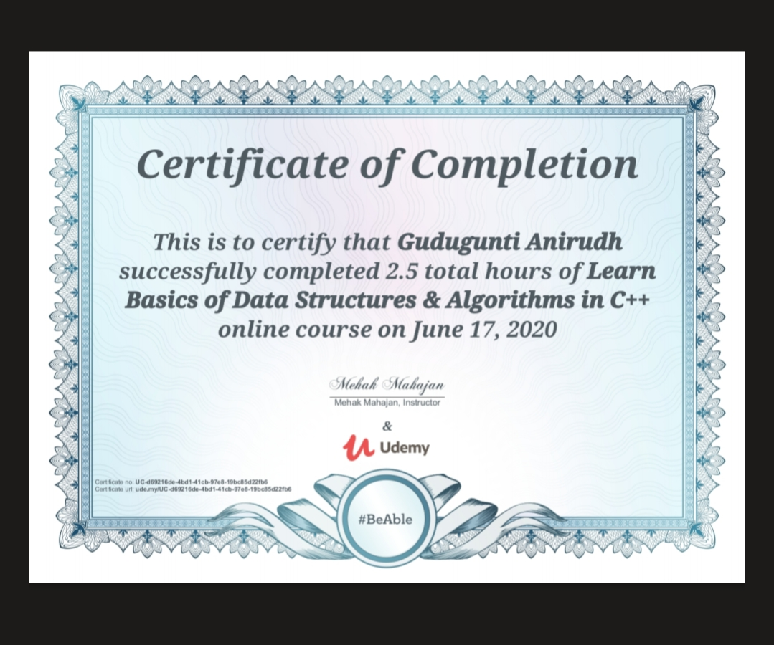

**Online coding:**

Problem 1: (using C language) program to binary reversal of a number.

